1.Enable CloudTrail monitoring and store the events in S3 and CloudWatch log events.
Enable CloudTrail Monitoring and Store Events in S3 and CloudWatch Logs – Step by Step
Step 1: Create an S3 Bucket
- Sign in to the AWS Management Console.
- Navigate to S3.
- Click Create Bucket.
- Enter a unique bucket name.
- Click Create Bucket.

Step 2: Create a CloudWatch Log Group
- Navigate to CloudWatch.
- In the left menu, select Logs → Log Groups.
- Click Create Log Group.
- Enter a log group name (e.g., CloudTrail-Logs).
- Click Create.

Step 3: Create an IAM Role for CloudTrail
- Navigate to IAM.
- Click Roles → Create Role.
- Select AWS Service as the trusted entity.
- Choose CloudTrail.
- Click Next.
- Attach the required CloudWatch Logs permissions.
- Enter a role name (e.g., CloudTrail-CloudWatch-Role).
- Click Create Role.

Step 4: Create a CloudTrail Trail
- Navigate to CloudTrail.
- Click Create Trail.
- Enter a trail name.
- Select Apply Trail to All Regions.
- Click Next.

Step 5: Configure S3 Storage
- Under Storage Location, choose Use Existing S3 Bucket.
- Select the S3 bucket created earlier.
- Enable Log File Validation.

Step 6: Configure CloudWatch Logs
- Enable CloudWatch Logs integration.
- Select the CloudWatch Log Group (CloudTrail-Logs).
- Select the IAM role (CloudTrail-CloudWatch-Role).

Step 7: Configure Event Logging
- Choose Management Events.
- Select Read and Write events.
- Keep the default settings unless additional logging is required.

Step 8: Review and Create
- Review all settings.
- Click Create Trail.

Step 9: Generate Test Events
- Open S3, EC2, or IAM services.
- Perform a few actions such as viewing buckets or instances.
- Wait a few minutes for CloudTrail to process the events.

Step 10: Verify Logs in S3
- Open the S3 bucket used for CloudTrail.
- Navigate through the folders:
  - AWSLogs
  - Account ID
  - CloudTrail
- Verify that log files are being generated.

Step 11: Verify Logs in CloudWatch
- Open CloudWatch.
- Go to Logs → Log Groups.
- Open the CloudTrail-Logs log group.
- Open a log stream.
- Verify that CloudTrail events are visible.

Validation
- CloudTrail status is Enabled.
- Log files are stored in the S3 bucket.
- CloudWatch Log Group contains CloudTrail log streams.
- AWS API activities are visible in CloudTrail Event History, S3 logs, and CloudWatch Logs.

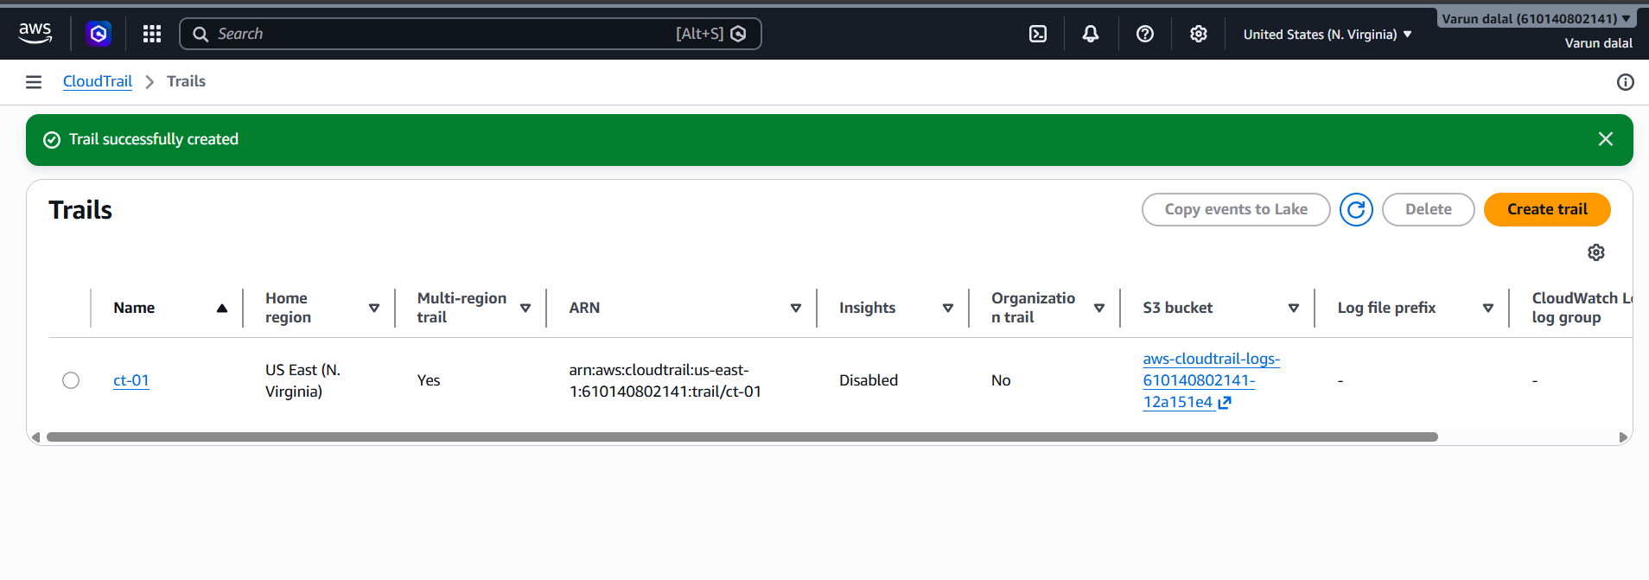
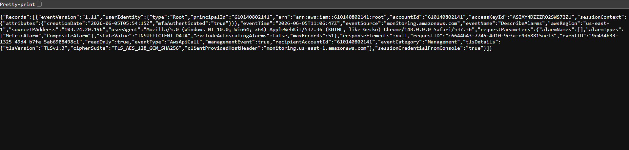

2.Enable SNS for CloudTrail to Send Alerts via Email – Step by Step
Step 1: Create an SNS Topic
- Sign in to the AWS Management Console.
- Navigate to SNS (Simple Notification Service).
- Click Topics.
- Click Create Topic.
- Select Standard.
- Enter a topic name, for example:
CloudTrail-Alerts
- Click Create Topic.

Step 2: Create an Email Subscription
- Open the newly created SNS topic.
- Click Create Subscription.
- Configure:
  - Protocol: Email
  - Endpoint: Your email address
- Click Create Subscription.

Step 3: Confirm the Subscription
- Check your email inbox.
- Open the AWS SNS confirmation email.
- Click Confirm Subscription.
The subscription status should change from Pending Confirmation to Confirmed.

Step 4: Create a CloudWatch Log Metric Filter
- Navigate to CloudWatch.
- Click Log Groups.
- Open the CloudTrail log group.
- Select Create Metric Filter.
- Enter a filter pattern.
Example (detect Console Login events):
{ $.eventName = ConsoleLogin }
- Click Next.
- Enter:
  - Filter Name: ConsoleLoginFilter
  - Metric Namespace: CloudTrailMetrics
  - Metric Name: ConsoleLoginCount
  - Metric Value: 1
- Click Create Metric Filter.

Step 5: Create a CloudWatch Alarm
- Navigate to CloudWatch → Alarms.
- Click Create Alarm.
- Select the metric created above.
- Click Select Metric.
- Set:
  - Statistic: Sum
  - Period: 5 Minutes
  - Threshold: Greater than or equal to 1
- Click Next.

Step 6: Configure SNS Notification
- Under Notification, select:
  - Alarm State Trigger: In Alarm
- Select:
  - Existing SNS Topic
- Choose:
CloudTrail-Alerts
- Click Next.

Step 7: Name the Alarm
- Enter an alarm name:
CloudTrail-ConsoleLogin-Alarm
- Click Next.
- Review the configuration.
- Click Create Alarm.

Step 8: Test the Alert
- Sign out and sign back into the AWS Console.
- Wait a few minutes for CloudTrail to record the event.
- CloudWatch detects the event.
- The alarm enters the ALARM state.
- SNS sends an email notification to the subscribed email address.

Validation
- SNS Topic is created.
- Email subscription is confirmed.
- Metric filter is created on the CloudTrail log group.
- CloudWatch Alarm is configured.
- Email notifications are received when matching CloudTrail events occur.
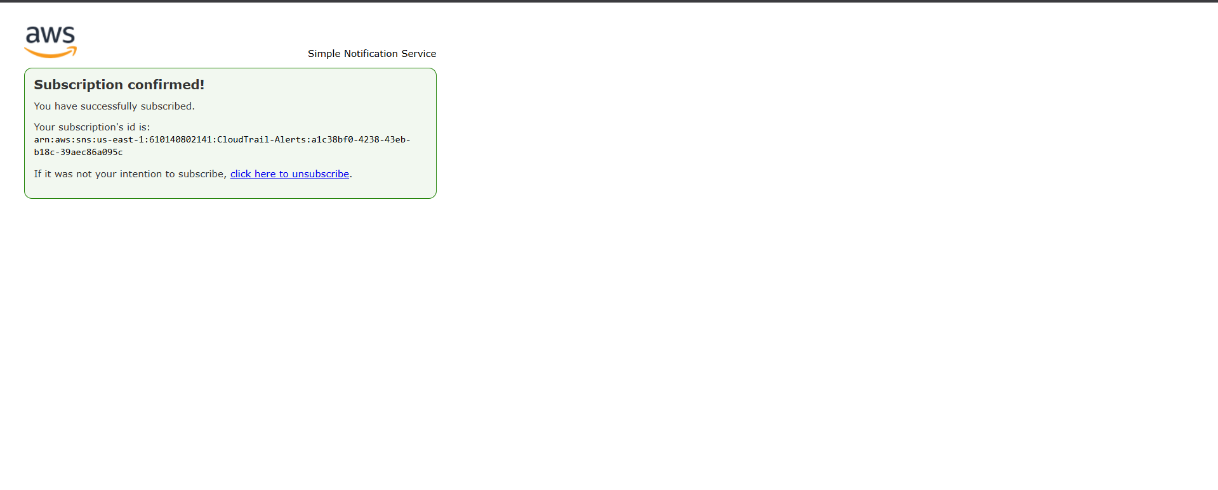

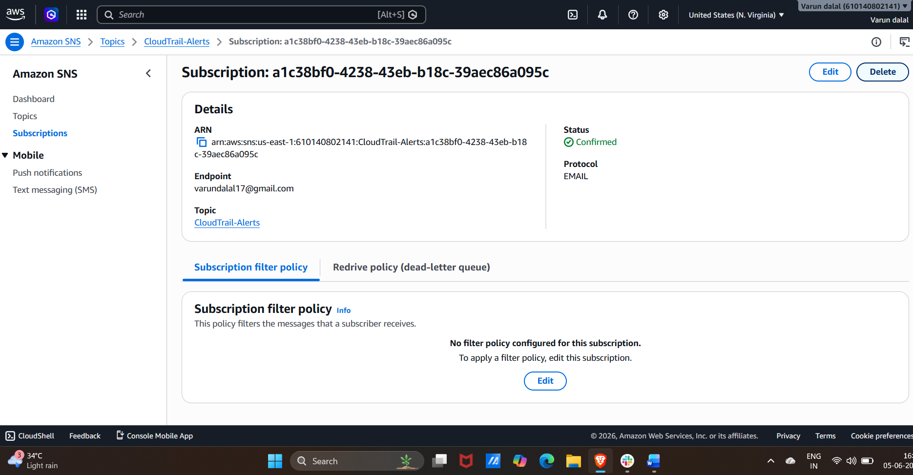

3.Configure CloudWatch monitoring and record the CPU utilization and other metrics of EC2
Step by Step
Step 1: Launch or Select an EC2 Instance
- Sign in to the AWS Management Console.
- Navigate to EC2.
- Launch a new EC2 instance or select an existing instance.

Step 2: Open the Monitoring Tab
- In the EC2 Console, select your instance.
- Click the Monitoring tab.
- View the default metrics being collected by CloudWatch.
Examples:
- CPUUtilization
- NetworkIn
- NetworkOut
- DiskReadOps
- DiskWriteOps
- StatusCheckFailed

Step 3: Enable Detailed Monitoring
- Select the EC2 instance.
- Click Actions → Monitor and troubleshoot → Manage detailed monitoring.
- Select Enable.
- Click Update.
This changes metric collection from every 5 minutes to every 1 minute.

Step 4: Open CloudWatch
- Navigate to CloudWatch.
- Click Metrics from the left menu.
- Select All Metrics.
- Open EC2.
- Click Per-Instance Metrics.

Step 5: View CPU Utilization
- Select the metric:
CPUUtilization
- View the graph showing CPU usage over time.

Step 6: View Additional Metrics
Select and monitor:
- CPUUtilization
- NetworkIn
- NetworkOut
- DiskReadBytes
- DiskWriteBytes
- DiskReadOps
- DiskWriteOps
- StatusCheckFailed

Step 7: Create a CPU Utilization Alarm
- In CloudWatch, click Alarms.
- Click Create Alarm.
- Select Metric.
- Choose:
  - EC2
  - Per-Instance Metrics
  - CPUUtilization
- Click Select Metric.

Step 8: Configure Threshold
- Set:
  - Statistic: Average
  - Period: 5 Minutes
  - Threshold Type: Static
  - Whenever CPUUtilization is:
    - Greater than 70%
- Click Next.

Step 9: Configure Notifications
- Select Create New SNS Topic or Use Existing Topic.
- Enter an email address.
- Click Next.

Step 10: Create the Alarm
- Enter an alarm name:
HighCPUAlarm
- Review the settings.
- Click Create Alarm.

Step 11: Verify Metrics Collection
- Return to:
  - CloudWatch → Metrics → EC2 → Per-Instance Metrics
- Verify that metrics are being updated.
- Check the CPU utilization graph and other instance metrics.

Validation
- EC2 metrics are visible in CloudWatch.
- Detailed monitoring is enabled.
- CPU utilization graph displays data.
- Additional metrics (Network, Disk, Status Checks) are available.
- CloudWatch alarm is created and monitoring CPU utilization successfully.
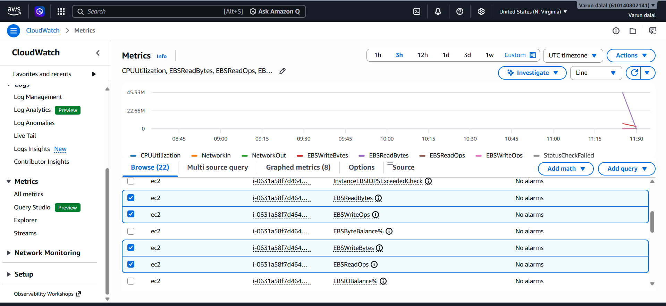
4.Create one alarm to send an alert to email if the CPU utilization is more than 70 percent
Create an Alarm to Send an Email Alert if CPU Utilization Exceeds 70%
Step 1: Open CloudWatch
- Sign in to the AWS Management Console.
- Navigate to CloudWatch.
- Click Alarms in the left navigation pane.
- Click Create Alarm.

Step 2: Select the CPU Utilization Metric
- Click Select Metric.
- Choose EC2.
- Select Per-Instance Metrics (or By Instance ID).
- Select your EC2 instance's CPUUtilization metric.
- Click Select Metric.

Step 3: Configure the Alarm Condition
- Statistic: Average
- Period: 5 Minutes
- Threshold Type: Static
- Whenever CPUUtilization is:
  - Greater than
  - 70
- Click Next.

Step 4: Configure Notifications
- Under Notification, select In alarm.
- Select Create new topic (or choose an existing SNS topic).
- Enter a topic name:
CPU-Alert-Topic
- Enter your email address.
- Click Create Topic.
- Click Next.

Step 5: Name the Alarm
- Enter an alarm name:
HighCPUAlarm
- Optionally add a description.
- Click Next.

Step 6: Review and Create
- Review the alarm configuration.
- Click Create Alarm.

Step 7: Confirm Email Subscription
- Check your email inbox.
- Open the AWS SNS confirmation email.
- Click Confirm Subscription.

Validation
- Go to CloudWatch → Alarms.
- Verify that HighCPUAlarm appears in the alarms list.
- Verify that the SNS subscription status is Confirmed.
- When CPU utilization exceeds 70%, the alarm state changes to ALARM and an email notification is sent to the configured email address.

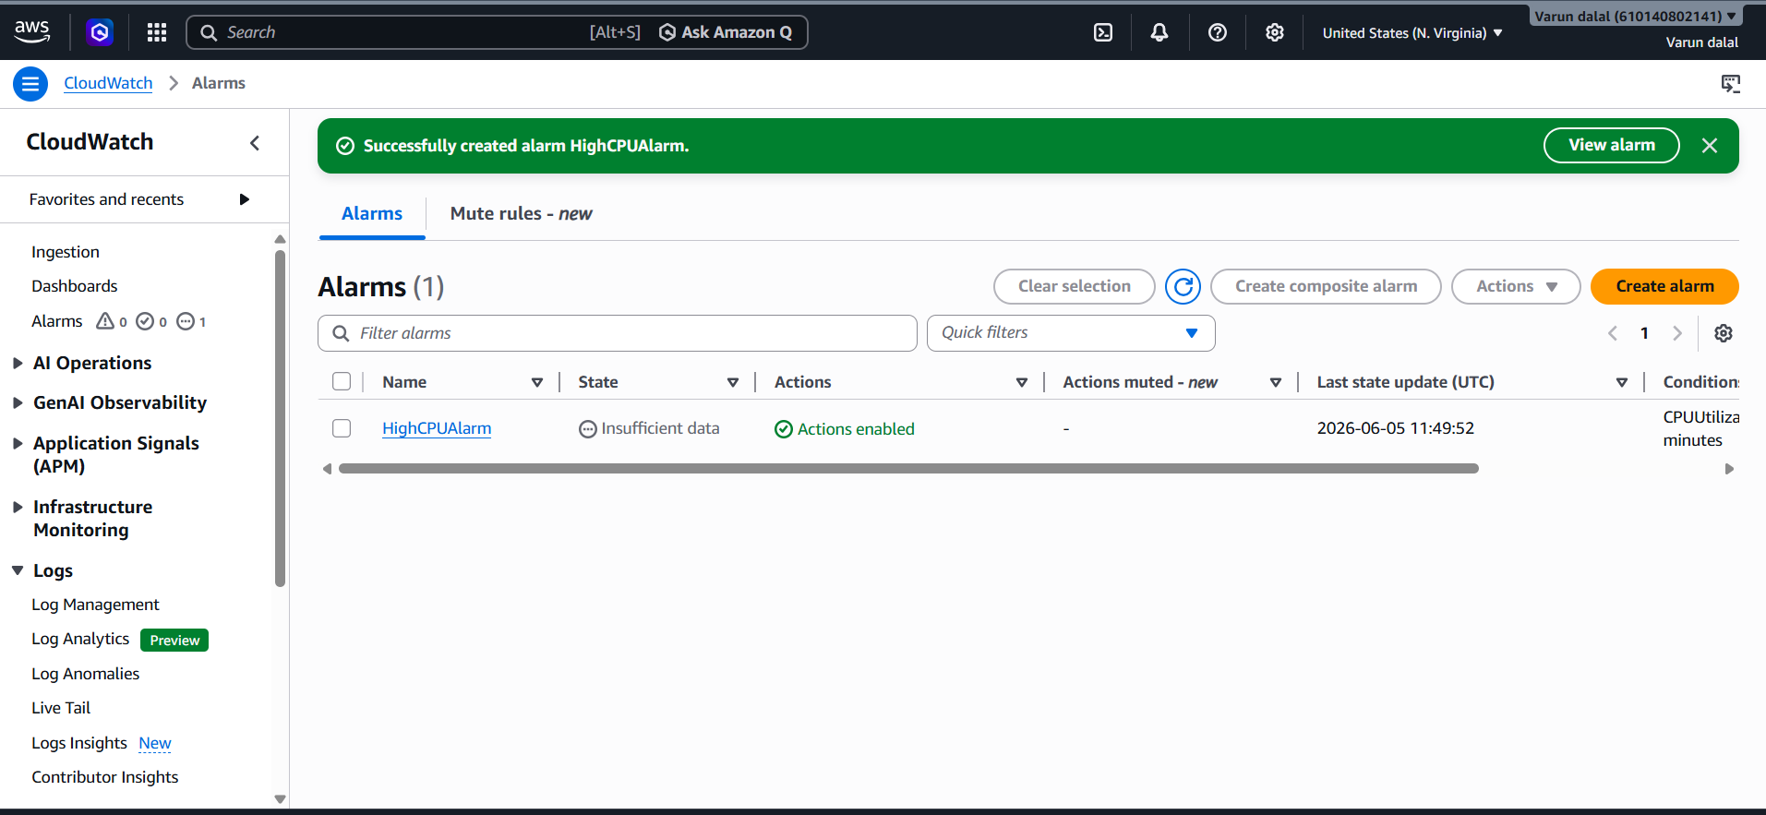

- Create a Dashboard and monitor the Tomcat service whether it is running or not and send the alert
PURPOSE: To create a monitoring dashboard that continuously tracks the tomcat service status on an EC2 instance and automatically sends alerts whenever the Tomcat service stops, crashes or becomes unavailable.
OUTCOME:
- A CloudWatch Dashboard displays Tomcat health and EC2 performance metrics.
- Tomcat service status is monitored every minute.
- An SNS email alert is automatically sent when Tomcat stops running.
- Operations teams can quickly identify and resolve service outages, improving application availability.

STEP BY STEP IMPLEMENTATION:
- Launch an EC2 instance and install tomcat in that service.
- Install cloudwatch agent in EC2 instance that you have launched.
- Write a bash script to monitor Tomcat status.
- For that we have create and run the tomcat.service file for systemctl commands execution.
- We have to create cronjob for monitoring Tomcat.
- In AWS account go to cloudwatch service and create a dashboard and also create a alarm for the monitoring of Tomcat service.
- We have to set a threshold for this that, if the threshold is 1 then alarm should be OK and if the threshold is lower than 1 then alarm should be triggered and send a notification to the user email by triggering SNS service.

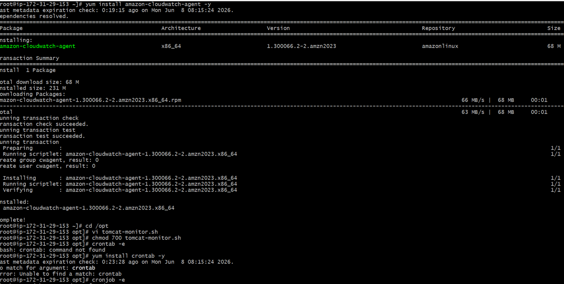
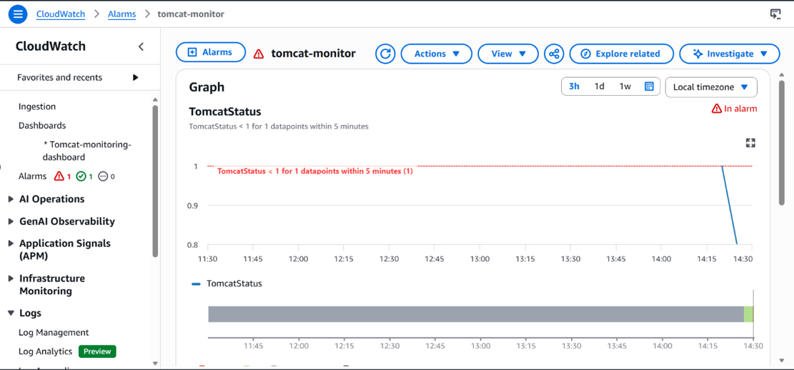

6.Create a Dashboard and monitor the Nginx service to send the alert if Nginx is not running
OBJECTIVE: To monitor the Nginx service running on an EC2 instance, visualize its status in a CloudWatch Dashboard, and automatically send alerts when the Nginx service stops or becomes unavailable.

OUTCOME:
- A CloudWatch Dashboard displays Nginx service health and EC2 metrics.
- Nginx status is checked every minute.
- Custom metric Nginx Status reports:
-> 1 = Running
-> 0 = Stopped
- CloudWatch Alarm detects service outages.
- SNS sends email alerts whenever Nginx is not running.

STEP BY STEP IMPLEMENTATION:

- Create an EC2 instance and download Nginx service.
- Download cloudwatch agent to push the metrics related to nginx server status.
- Then write a script to check the status of server and send the metrics to the cloudwatch.
- We have to set a threshold for this that, if the threshold is 1 then alarm should be OK and if the threshold is lower than 1 then alarm should be triggered and send a notification to the user email by triggering SNS service.
